
Touchstones Project
Netcards

Hope Netcards with Text

Alive HRJ
Bird Singing HRJ
Bread HRJ
Bud HRJ

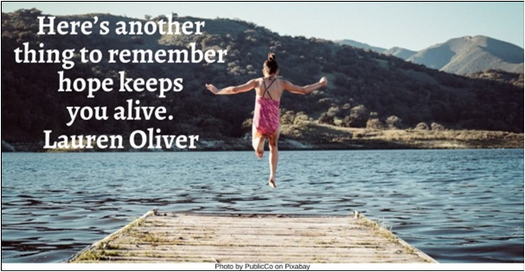

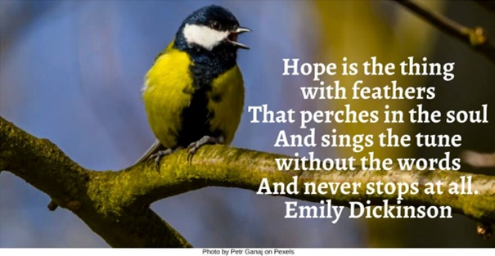

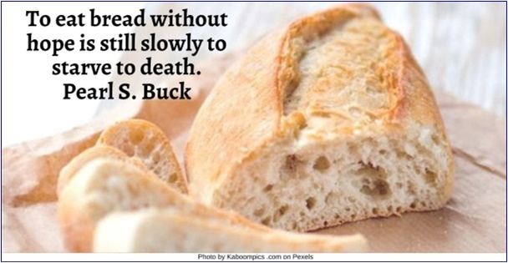

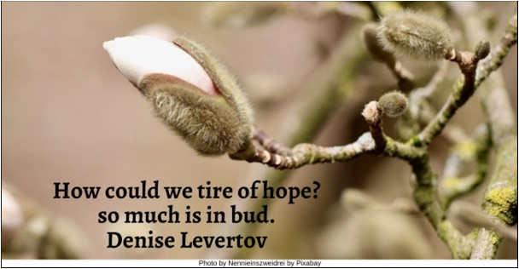

Candles HRJ
Creation HRJ
Dark HRJ
Desolation HRJ

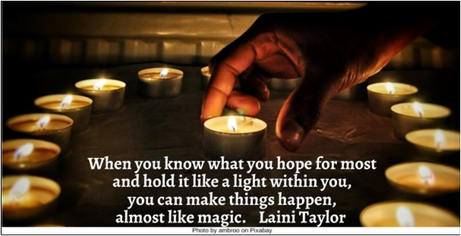

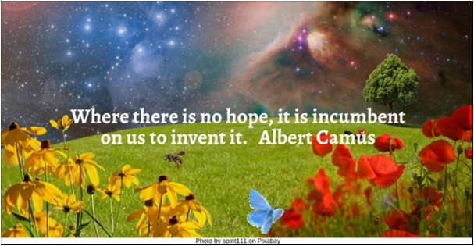

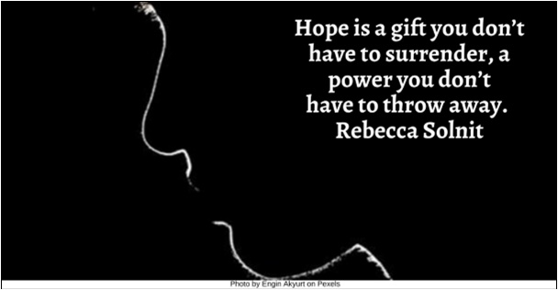

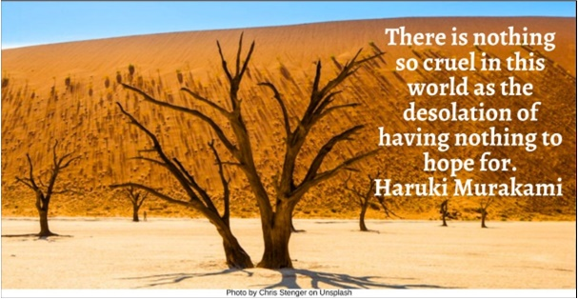

Despair and Hope HRJ
Despair HRJ
Determined HRJ
Doors HRJ

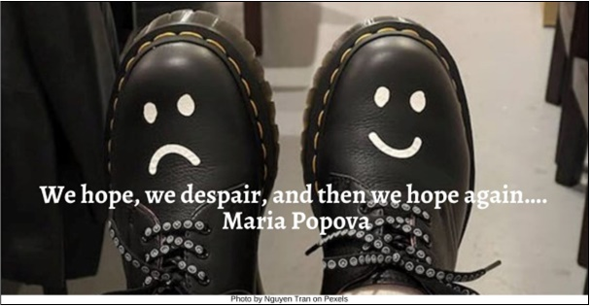

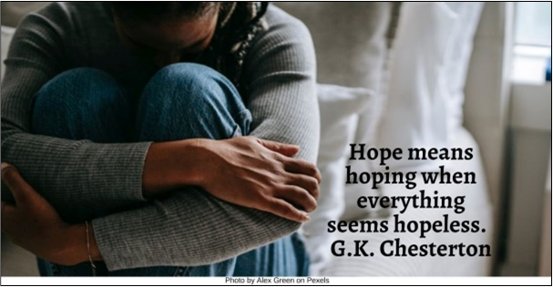

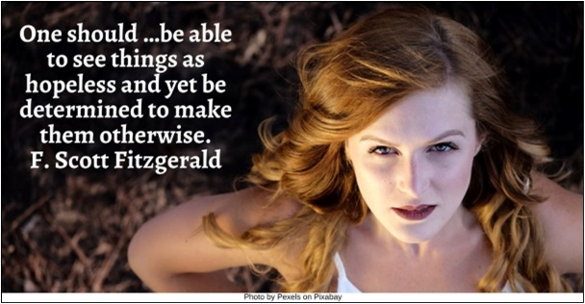

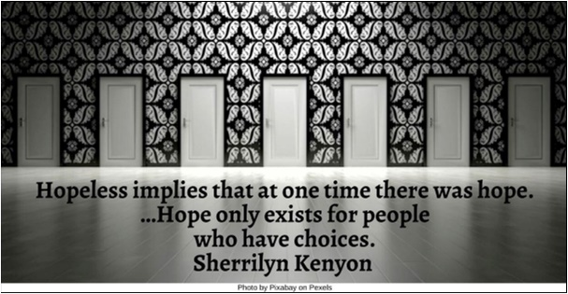

Gift HRJ
Hand HRJ
Hope HRJ
Hope to Action HRJ

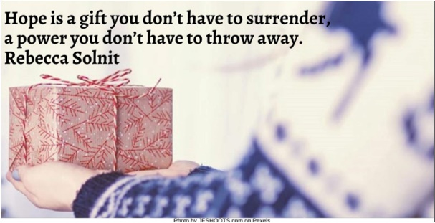

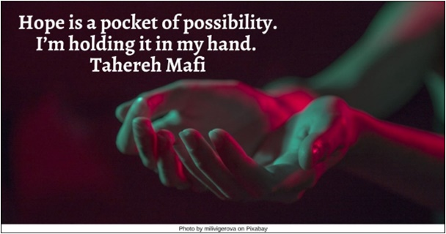

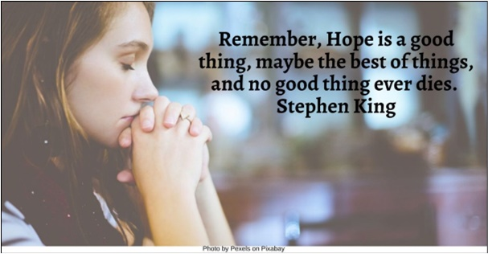

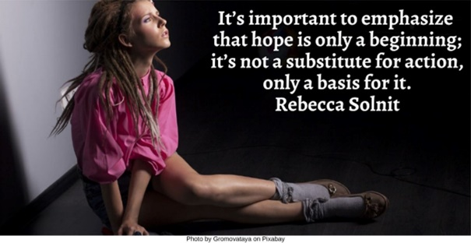

Hopeful HRJ
Hopeless HRJ
Hourglass HRJ
Hubble HRJ

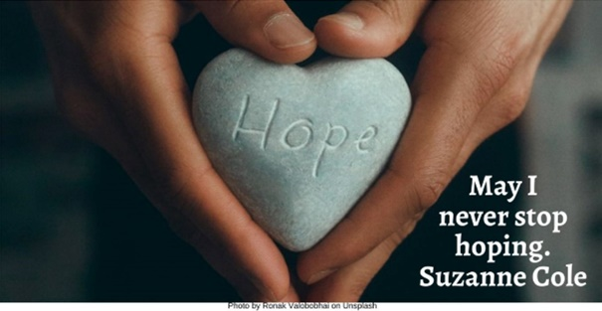

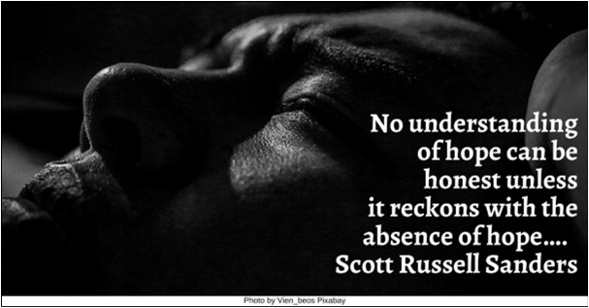

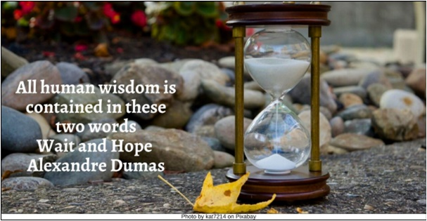

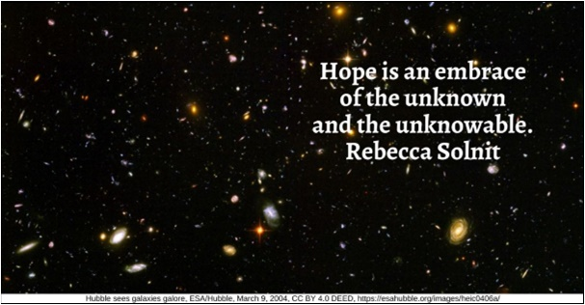

I Rise HRJ
Infinity HRJ
Love HRJ
Martin Luther King, Jr HRJ

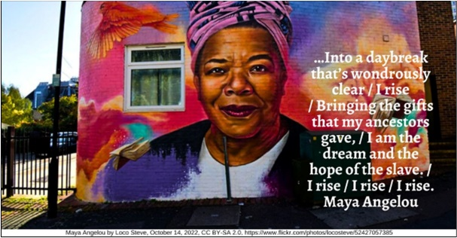

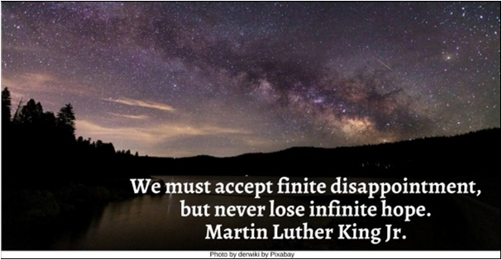

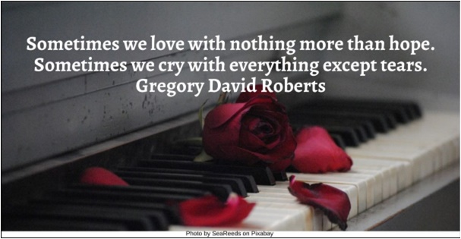

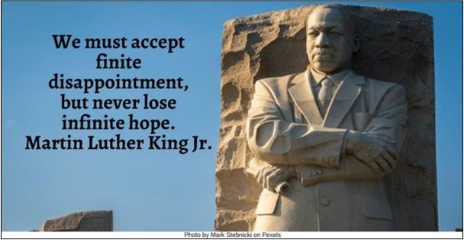

Piggy Bank HRJ
Possibility HRJ
Small Plant HRJ
Spring HRJ

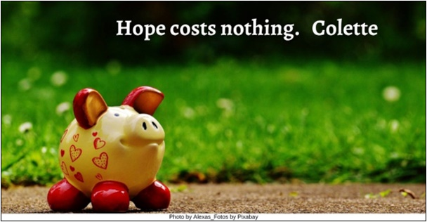

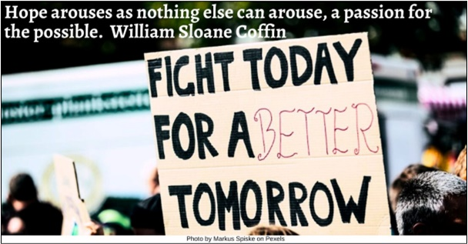

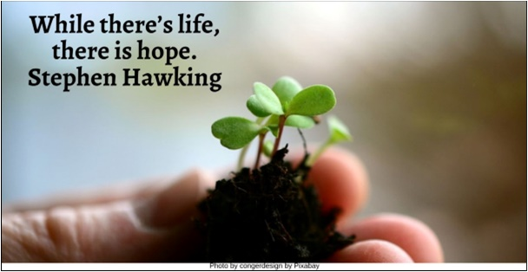

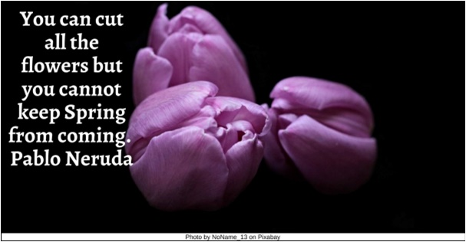

Stars HRJ
Window HRJ
Without Hope HRJ

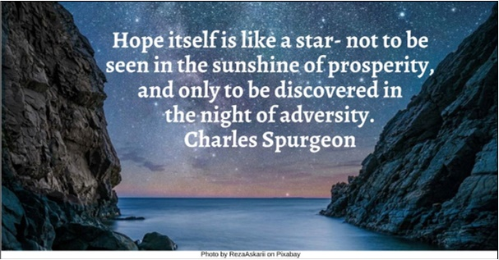

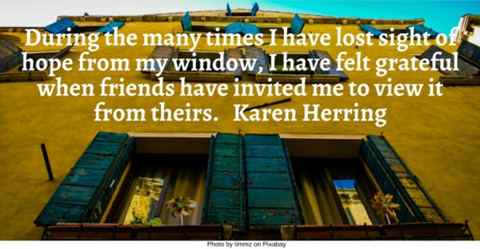

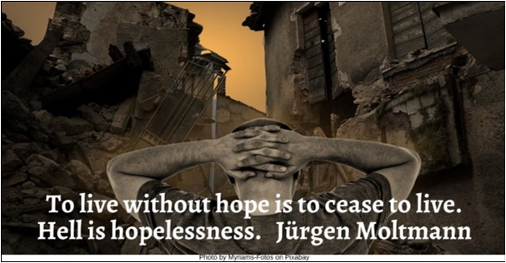

Text of Quotes
Alive HRJ
Here’s another thing to remember: hope keeps you alive. Lauren Oliver

Bird Singing HRJ
Hope is the thing with feathers / That perches in the soul / And sings the tune without the words / And never stops at all. Emily Dickinson

Bread HRJ
To eat bread without hope is still slowly to starve to death. Pearl S. Buck

Bud HRJ
How could we tire of hope?
— so much is in bud.
Denise Levertov

Candles HRJ
When you know what you hope for most and hold it like a light within you, you can make things happen, almost like magic. Laini Taylor

Creation HRJ
Where there is no hope, it is incumbent on us to invent it. Albert Camus

Dark HRJ
Hope begins in the dark, the stubborn hope that if you just show up and try to do the right thing, the dawn will come. Anne Lamott

Desolation HRJ
There is nothing so cruel in this world as the desolation of having nothing to hope for. Haruki Murakami

Despair and Hope HRJ
We hope, we despair, and then we hope again…. Maria Popova

Despair HRJ
Hope means hoping when everything seems hopeless. G.K. Chesterton

Determined HRJ
One should …be able to see things as hopeless and yet be determined to make them otherwise. F. Scott Fitzgerald

Doors HRJ
Hopeless implies that at one time there was hope. …Hope only exists for people who have choices. Sherrilyn Kenyon

Gift HRJ
Hope is a gift you don’t have to surrender, a power you don’t have to throw away. Rebecca Solnit
Photo by JESHOOTS.com on Pexels

Hand HRJ
Hope is a pocket of possibility. I’m holding it in my hand. Tahereh Mafi

Hope to Action HRJ
It’s important to emphasize that hope is only a beginning; it’s not a substitute for action, only a basis for it. Rebecca Solnit

Hope HRJ
Remember, Hope is a good thing, maybe the best of things, and no good thing ever dies. Stephen King

Hopeful HRJ
May I never stop hoping. Suzanne Cole

Hopeless HRJ
No understanding of hope can be honest unless it reckons with the absence of hope…. Scott Russell Sanders

Hourglass HRJ
All human wisdom is contained in these two words—Wait and Hope Alexandre Dumas

Hubble HRJ
Hope is an embrace of the unknown and the unknowable. Rebecca Solnit

I Rise HRJ
…Into a daybreak that’s wondrously clear / I rise / Bringing the gifts that my ancestors gave, / I am the dream and the hope of the slave. / I rise / I rise / I rise. Maya Angelou

Infinity HRJ
We must accept finite disappointment, but never lose infinite hope. Martin Luther King Jr.

Love HRJ
Sometimes we love with nothing more than hope. Sometimes we cry with everything except tears. Gregory David Roberts

Martin Luther King, Jr HRJ
We must accept finite disappointment, but never lose infinite hope. Martin Luther King Jr.

Piggy Bank HRJ
Hope costs nothing. Colette

Possibility HRJ
Hope arouses as nothing else can arouse, a passion for the possible. William Sloane Coffin

Small Plant HRJ
While there’s life, there is hope. Stephen Hawking

Spring HRJ
You can cut all the flowers but you cannot keep Spring from coming. Pablo Neruda

Stars HRJ
Hope itself is like a star- not to be seen in the sunshine of prosperity, and only to be discovered in the night of adversity. Charles Spurgeon
Window HRJ
During the many times I have lost sight of hope from my window, I have felt grateful when friends have invited me to view it from theirs. Karen Herring

Without Hope HRJ
To live without hope is to cease to live. Hell is hopelessness. Jürgen Moltmann

